Application Design
In the main frame, we need to select the user identity first by clicking the button. The Administrators part is used for teacher to view students’ general information and get the ranking of the graduate students. And in student part, it allows student to add and edit their personal information and job situation.
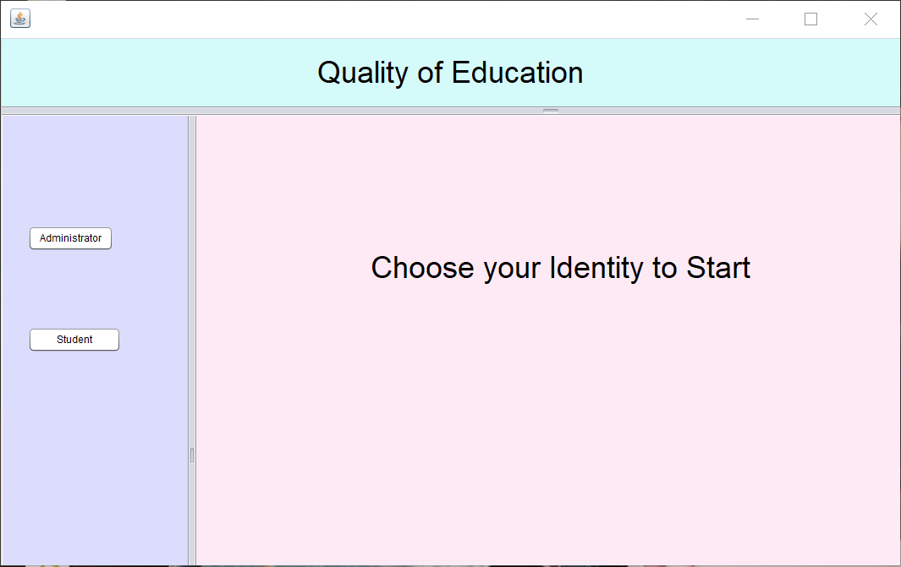

Administrator Part
In the administrator part, before user start to view, they need to use their id number to login.
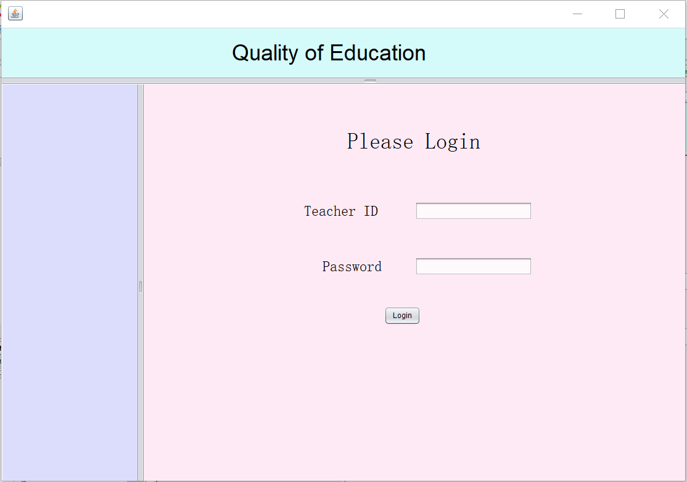

After successfully login, it will appear this interface, which is the student general information that include student name, company, salary, and graduate date. When click the rank by salary button in the lower left corner, the data in the table will displayed in the order of low to high wages. When click the integrated rank button, it will be based on our algorithm scores to sort an integrated ranking. Both sorts allow administrator to have a rough idea of student situation. At the same time, the administrator can also select a row of students and click the view detail button to view the detail information of that student.
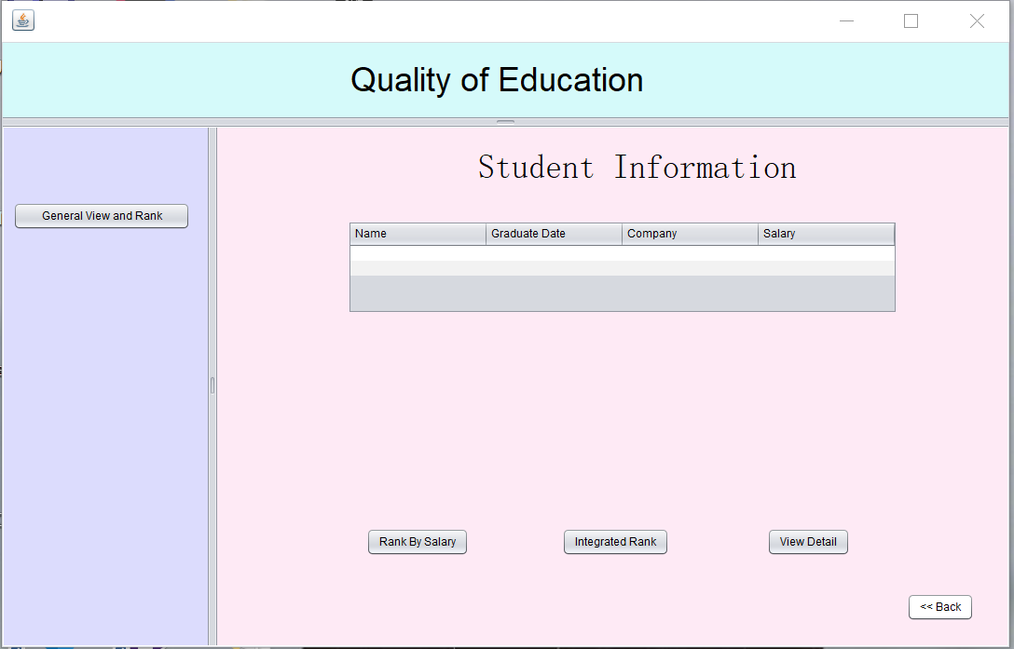

This is the interface of view the detail information of specific student. The top half of the interface is the basic personal information of the student. The following course table shows information about all the courses student took during the whole study process. Connection expresses the degree to which the student thinks the subject is relevant to his current job. The bottom work information table shows the details of the student's work information, which including the company, salary, promotion situation and the overall evaluation of curriculum relevance to the job.
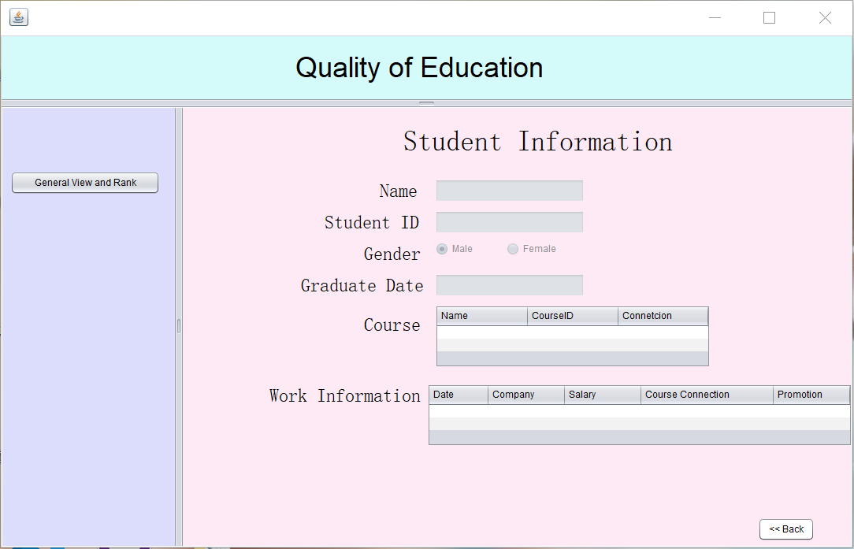

The left side button on both these two pages is used for administrator to go to the student general information page, which is also the first page.

Student Part
As for the student part, before any operation it also requires student to login with their student id first.
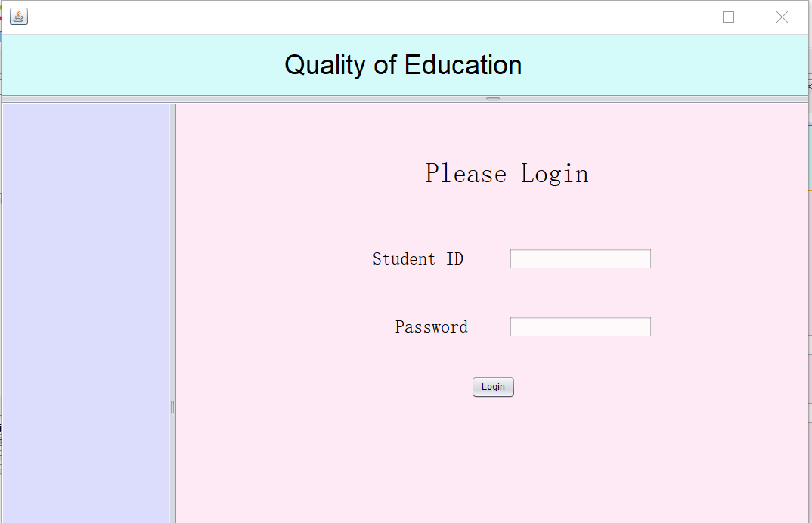

Once the student successfully logs in, the interface will jump to the student information page. Similar with the student information page at administrator part, the top half of the page is the student's personal basic information. The bottom half of the page has two tables, course table and job information table. In course table, if student select one of the rows and click the view details button on the left, the page will jump to edit course connection page, which student can view and modify the connection between the course and job. Similarly, if the student selects a row in the work table, and click the view details button on the left, the page will jump to add or edit job information page, which student can check and change the job detail.
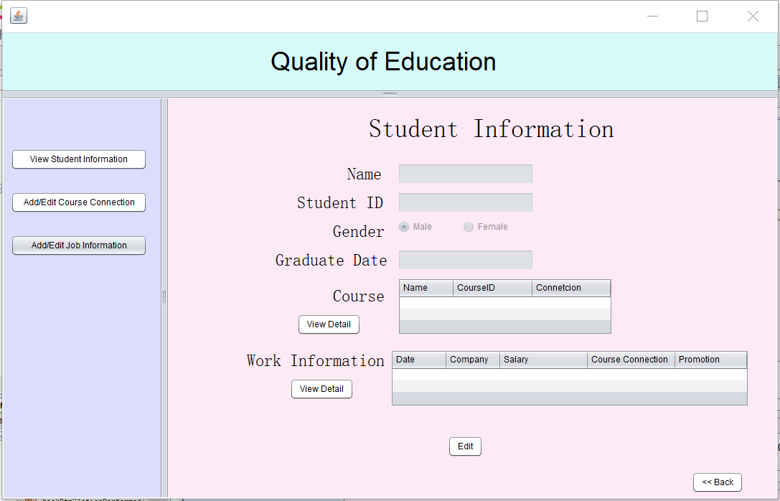

The course edit page allows students to adjust how much they think the course is relevant to their current job. They can drag the button to express the percentage of relevance they think. Of course, on this page, they can only go changing the degree of relevance, which means they does not allow to modify other content, such as the course name or course ID.
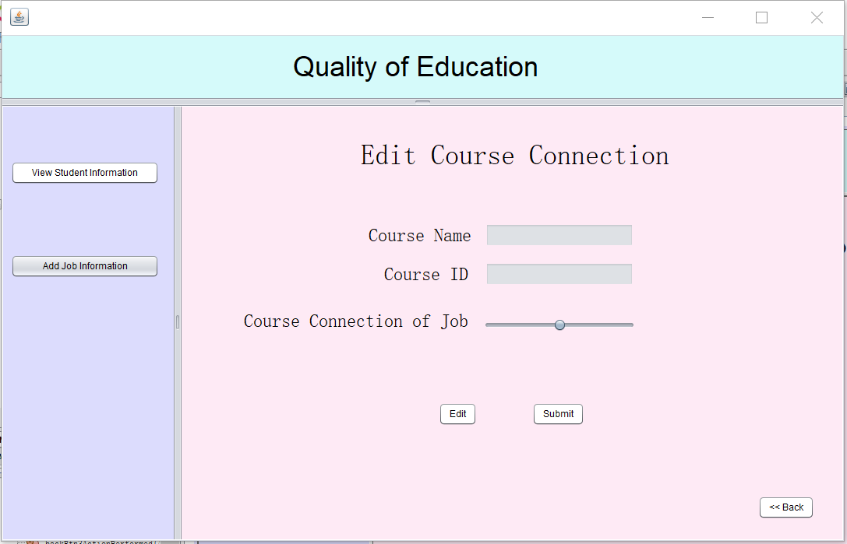

In the job information interface, students can view and modify their company names, positions, and salaries. In the promotion option at the bottom, student can click on two radio buttons to choose whether they have been promoted. And the one submission of a promotion will get a bonus points in subsequent rankings. The application will also get the update time automatically when student click submit.
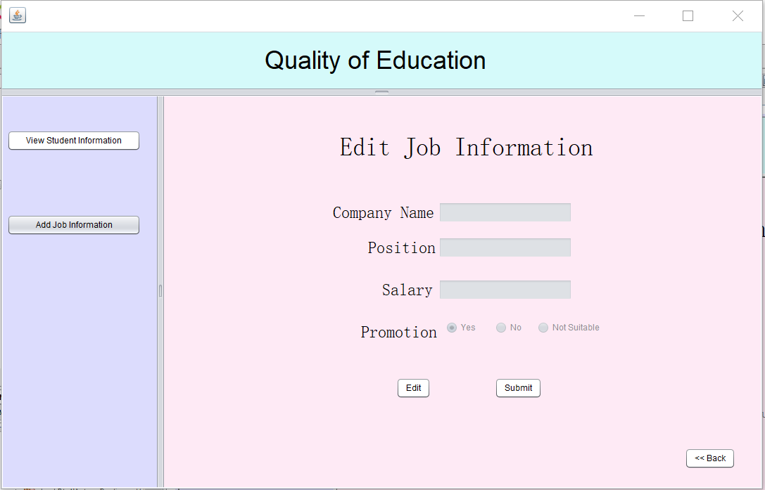

Besides these three pages, the button on the left also allow student to go to the student information page or go to add some work changes. The add job page is extremally similar with the edit page.
